**Boy A**

Age:18

Birthday: 20/01

Blood Type: A

Sex: M

Name: Yuuto Makoto

Personality: Pervert, Lazy, A bit smart

Height: 180

**Girl A**

Age:17;

Birthday: 20/07

Blood Type: O

Sex: F

Name: Ayumi Natsuko

Personality: Outgoing, curious

Height: 168

  
Failure. Failure was everything it was inside my head, as the moon casts my shadow on the sidewalk to my way home.

Y -Sigh…

Y -When it will just finish? It seems like my finals will last for a while…

I murmur to myself as I walk.

A few hours ago, I was in the examination room alone because everyone in my class passed. Like I would care.

I handed over the empty exam paper and headed home without any care in the world. Maybe I didn’t have to play the new released game until morning. It was getting late and the moon is getting brighter and brighter as I distance myself from my school. I had to move quick or I would be late for the in-game event.

[…]

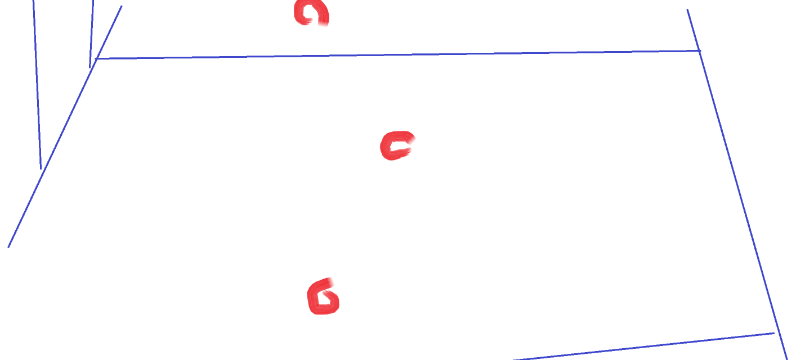

As I keep going, I notice small droplets of blood on the ground, As I walked more and more the droplets would become bigger and bigger where they would lead to a back alley, scared and curious at the same time, armed with a cutter knife that I forgot to give back to the class rep., I let my feet go forward.

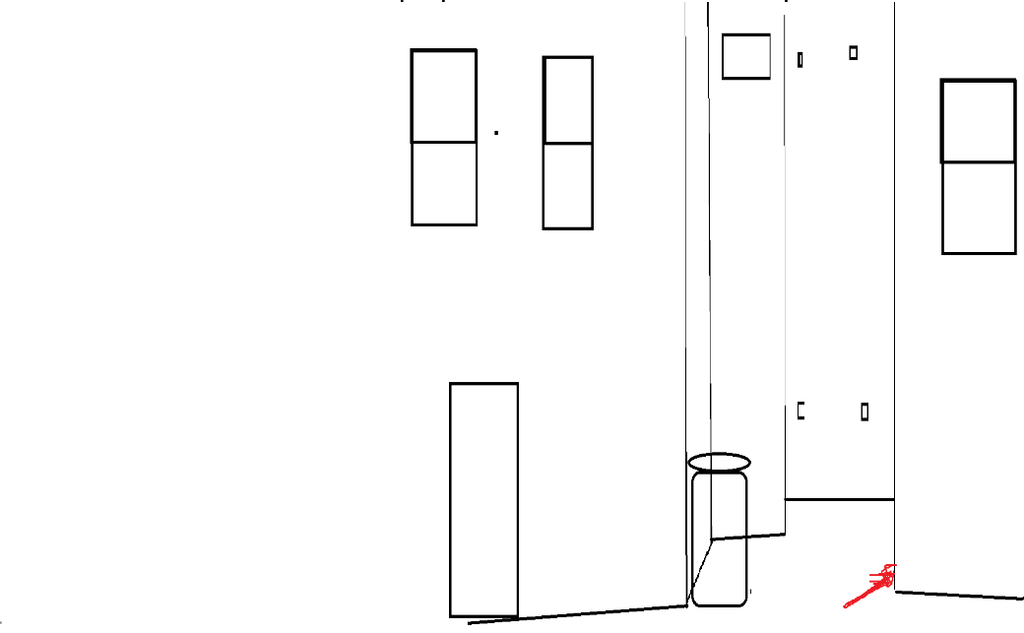 I look in every direction with every step I make, and, on the back corner behind a big pile of trash bags, I see a body that could barely move.

I lastly check the area around one me time and go to the body. Lastly, for my own safety, I prepare the knife towards the body if something would happen.

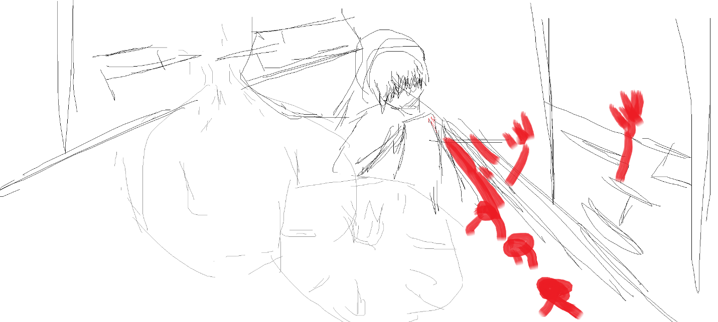

The body was of a young girl, with messy black hair and bloody clothes. I listen to her heartbeat if she was still alive.

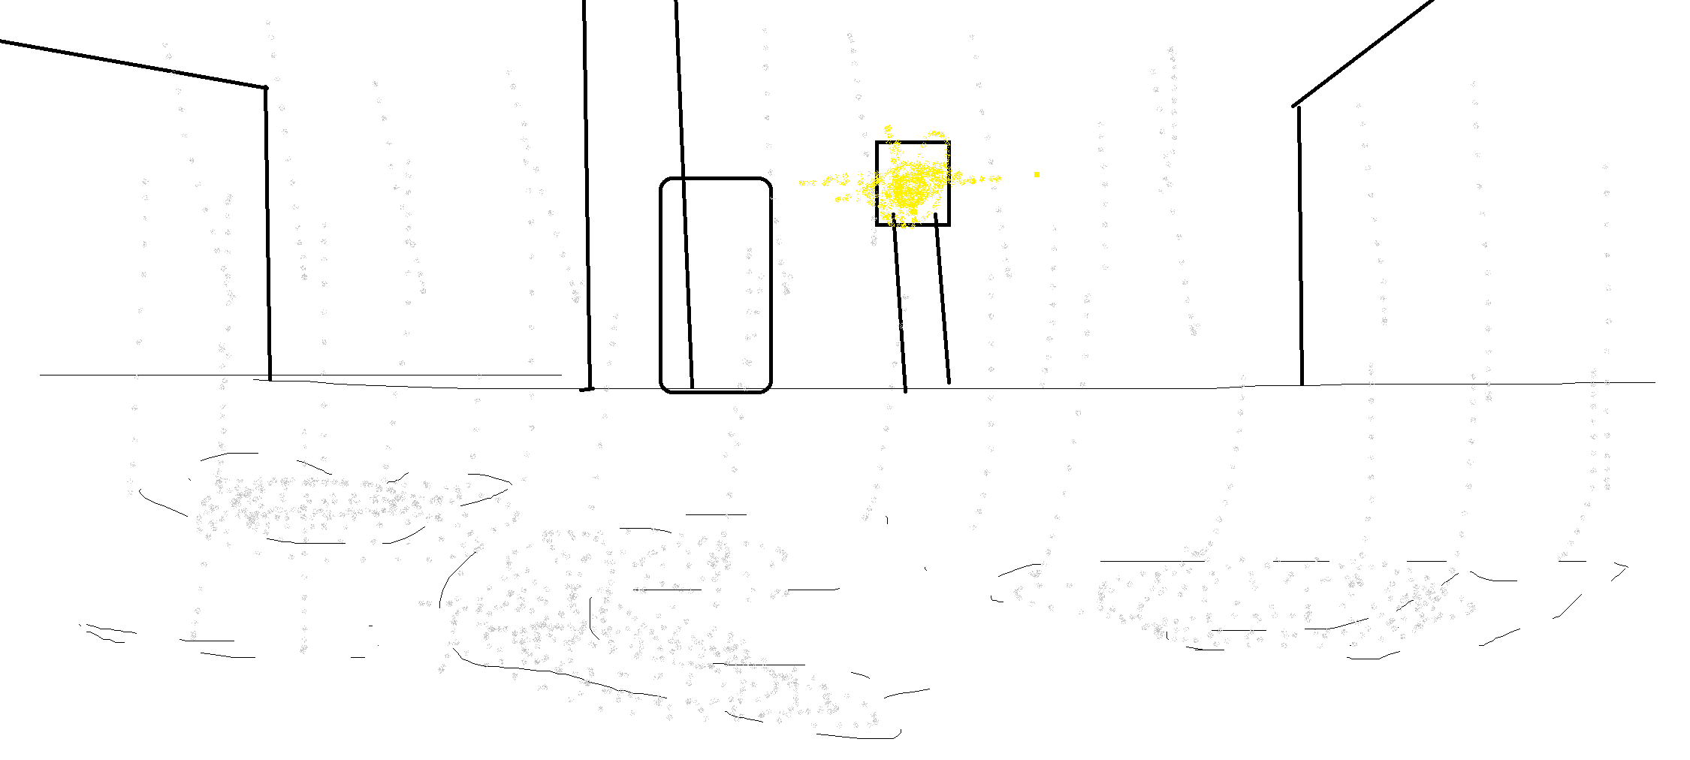 I could hear a very weak heartbeat that would slowly decrease and increase the beats per minute. I put down my bag and take my half-full bottle of water and open it. I open her mouth and give her a little bit of water, but not too much to make her suffocate. I splash a bit of water on her face and take off my shit and salvage it to make some makeshift bandages. I carefully roll the bandages on her shoulder; it was a deep cut so I placed the bandages gently. Last of all. I took my phone out of my pocket and decided to call the emergency service. As soon as I would press the button to begin the call, her hand grabbed my forearm. I could hear a very faint voice:

(BLACK SCREEN)

A -No…

A -Don’t… call…

As soon as possible I gave her some water to drink by opening her mouth gently.



Still, I started to question her why I should not call, but she doesn’t reply. I lastly said to her if she was hungry and she slowly nodded her head. At school I planned to not eat my lunch, but because of the boredom of waiting outside of the examination room, I ate it. Damn my bad luck is hitting at the wrong time again. Just how bad can it be? I told the girl that I will find some food to eat and not to move even one inch. I went to the nearest store and grabbed an apple. It started to rain. When I came back, she was nowhere to be found. I question myself if I was hallucinating because I didn’t sleep last night from too much item farming. I look back at the drops of blood on the sidewalk, but they vanished, the rain washed them away.

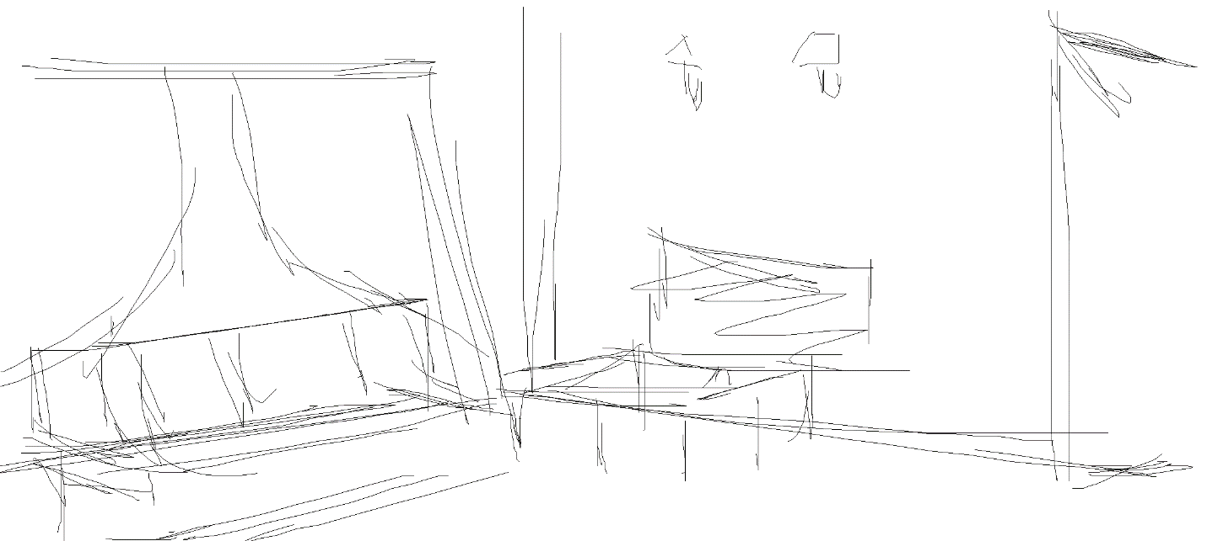

I arrive home, late, tired, all my body including my backpack was wet. I pulled out everything from my backpack and prepare to take a bath. I let my clothes dry on the drying racket, and head off to the bath. A few minutes passes by and I let my mind wash away everything that happened today. IF it happened. As I pull out the drain from the bathtub, I take my pajamas and head off to bed.



With clouds

In a few hours the awaited game event will start, so, I will rest for a while. As I closed my eyes, I could hear some footsteps outside my house. Firstly, I thought they were some delinquent kids walking by, but the footsteps would not stop. Grabbing my cutter again and my sleepers I head out outside. I open the door and look left and right carefully. There was nothing. I decided to check the back of my house but there was nothing as well.

Y -I think I hallucinated enough for today. I don’t even care at this point already.

I close the door and head off to bed again. But… as I think back… the door handle… was a bit warm…

…



The sun rays entered my room and hit my eyes.

I woke up.

I look at the clock at my right and I silently murmur…

Y -NO WAY I SLE- F-.

It seems I missed my awaited 1-year event. My bad luck hit again. I sighed. For the last time. Because sighing will not help with anything at this point anyway. Well… I think I’ll sleep more.



Suddenly, my phone made a sound I didn’t hear for a long time. And, it fact, it was the notification sound. Being already pissed and nervous, I open up the notification, which it would prompt me to a text message from an unknown number.

The following text was: “Meet me. We need to talk. Now.” And there was attached some GPS Coordinates.

Thinking it was another spam text or accidental texting. I ignore it. The next minute I receive a text message from an unknown number, again.

“Meet me. Yuuto Makoto.” I got a chill down my spine.

Deciding that my life was boring anyway. I entered the GPS Coordinates and I could see the location was… in front of my house. I got really scared. Taking my poor cutter again unsuitable for close quarter combat, I prepare myself, take a long breath and open the door. As I open the door…

(background)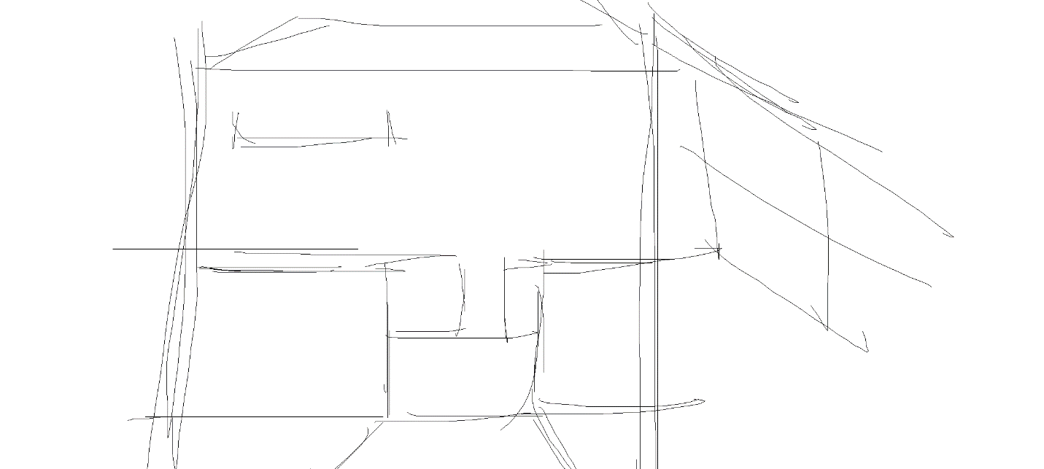

The first thing I would see was a girl of the same age as me, holding a cellphone on her right hand with a smile on her face. She had straight black hair , blue eyes, and soft pink lips. She wore ….

The girl looked into my eyes and gently opening her mouth preparing to say something.

A -Thank you for saving me!

As I get confused, I say…

Y -…what?

A -Thank you for saving me the other day!

Y -What are you talking about? Who are you?

A -You are the one who discovered me behind that big pile of trash, do you remember it right? Right? Right?

Y -Uh…

A -You took off your own shirt and cut it to make bandages to help me! Right? Right?

Now as I think about it, I really forgot about what happened yesterday, I thought I was hallucinating for not sleeping like an actual human being even if I got home and the ev-

A -Hey!

A -Are you there?   
I woke up from my overthinking.

I gently touched her face to see if she was real and my senses would not lie to me. I started to poke her soft cheeks. The girl took a few steps back and whispered;

A -Perv.

Y -Sorry, Sorry… I just wanted to see if you were real.

A -What are you saying, silly. Of course, I am real. You are having a conversation with me right now. If I was not real, you would not be outside right now.

I guess she is right, but still…

Y -Did the events from yesterday really happened? What happened to you? Who are you? Why did you run away?

A -Hey… I can’t answer so many questions you know… my head is starting to get dizzy.

A -Ne-Ne, can I enter your house?

As I lower the cutter and put it in safety mode in my pocket, I allow her to enter.

As she entered my house, she headed to my kitchen, like she was already knowing the route.

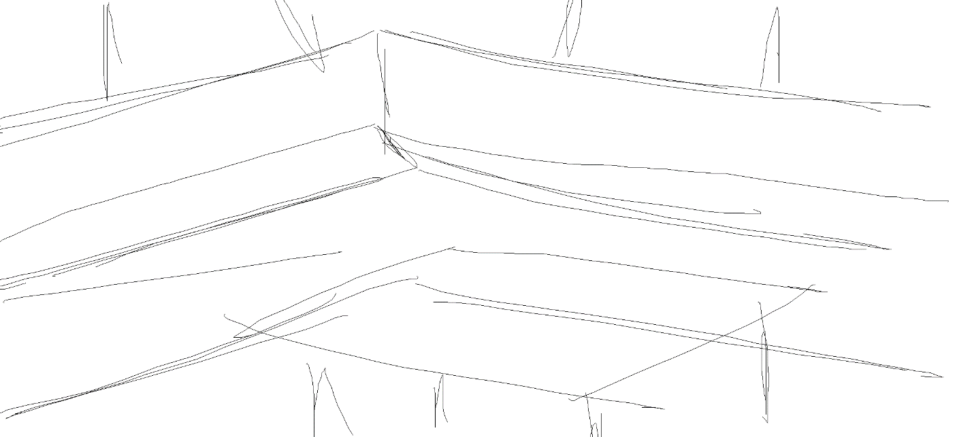

She sat on a chair in the kitchen. I sat in front of her.

She started to take out a piece of a glowing rock out of her bag and puts it in the table.

A -See, this rock is apparently a piece of meteorite that passed Earth 2 million years ago, the meteorite has traveled from the Alpha Centaury system to the Sol system 1 billion years ago, in that following time it has accumulated a lot of cosmic radiation that has godly proprieties of manipulating biological material in a short amount of time. This may seem a simple piece of rock but it’s the world’s most valuable asset. The rock was for centuries in the hands of the world’s most powerful people in history. It was found first in the Sumerian civilization 6000 years ago, it could be said the rock was a gateway to communicate with the gods and other high omnipotent deities, The Rock, travelling from hand to hand around the world, it created new civilization and religions, it created wars. The one that owned The Rock. It was the one who could control the world. The Rock after World War II, it was nowhere to be found, and so, the world started to be more peaceful. Until for now. A few months, a group of tourists in Papua New Guinea found it, sparkling the call of the United Nations, of securing it at site.

In the meantime, The Rock had to be transported, a theft occurred. It was a theft by the religious organization, thinking that the rock should be casted away in space from where it belongs. The United Nations gave up on the plan of securing it, because it would be a waste of resources in gathering a non-sense rock, because at the time of discovery, the effects of it disappeared.

The religion organizations gave up too.

Now you see, I found this rock washed it ashore on the beach.

As I grabbed it in hand a group of men in black suits chased me down. Thinking that no one should ever touch the rock. I ran away from the beach and tried my best to hide around the school that you go. As I began to be relived, I felt something strong on my shoulder. I felt a hot sensation and, looking down, I saw blood drops on the sidewalk. I thought I would die soon, so I went to the alley way to die without no one having me seen. And then you came and helped me get my strength back and run quickly because those men in black could chase me too there. I started to follow you to your home and looked for an entrance to sleep there. As I saw you open the door, I entered and slept in the bathroom. I gave you some sleeping fluid on your nose to not wake up. And I… I wanted to make you a bit scared (laughs).

So yeah… that’s the story.

Y -What. Did I. Listen. To.

A -Sorry, Heee~

Y -You even slept inside my house to begin with…

Thinking back, I think that’s how she knows my number and my name…

A -Sorry… I didn’t have nowhere to sleep… My house is already destroyed, I think.

After all she went through… I may…

Y -Hey…

A -Yes?

Y -Wanna live here until the situation cools down a little?

A -But I will be a bother you know.

Y -It’s fine…

Looking at her face again… She is kinda cute so…

A -Don’t tell to anyone about what I Talked to you!

Y -Uh…

I don’t have someone to talk to anyway…

Y -Anyway, what’s your name?

A -My name is Ayumi Katsuko~

A -You can call me Ayuko if you like.

Y -Okay, Ayuko-chan.

As I look at her, she gets up and starts looking around

Y -Is there something you want, Ayuko?

A -Yes…

A -I would need some aluminum foil.

Y -Aluminum foil? For what?

A -As The Rock emanates high amounts of electromagnetic wavelengths, it can be easily found with common equipment, and for our safety to not get killed over a piece of stone, we need to cover it in aluminum foil, because aluminum has the property to block the wavelengths from it, so we will not be detected so easily.

I don’t really cook because most of the food I eat is instant food from convenience stores, as they are quick to cook, as cooking is a waste of time…

Y -We could go out and buy some aluminum foil, I don’t have any of it right now…

A -Sorry… but we can’t go out…

Y -Huh? Why?

A -I am being chased by those men in black that I explained you earlier.

Y -Oh… so that means I have to go by myself?

A -Exactly.

Y -But they won’t recognize me that I interacted with you yesterday? They could kill me

A -They don’t know you, but if they find out I am together with you, they can.

As Ayuko wanders her eyes around, she focuses on the kitchen knife from the holster.

Y -What are you planning to do with that thing?

A -Watch.

As Ayuko grabs the knife firmly she points the knife tip to her point finger of her left hand, she stops, takes a deep breath and points the tip until a few drops of blood would come out. She puts the knife on the table and grabs The Rock. The Rock somehow changes Ayuko’s eyes; They were glowing with a light blue color and the wound has self-healed in a matter of seconds. If I think about it, she could use this technique to escape from the back alley yesterday.

A -The Rock has the power of, when it makes contact with the blood of the holder, to sharpen the 5 senses of the human being, the auditory, visual, olfactive, touch and taste. Now I can keep watch of you if something will happen. Don’t worry about it.

As my eyes didn’t believe what I saw, I was still amazed by what my brain perceived with my own eyes.

A -Let’s go out, shall we?

Y -Yeah…